**Program 5: Missionaries and Cannibals Problem**:

Aim : To write a Python program to solve the Missionaries and Cannibals problem using state-space search and ensure that missionaries are never outnumbered by cannibals on either bank.

Algorithm

1. Start the program and import necessary libraries (e.g., collections for BFS).
2. Define a structure for the left bank (number of missionaries, cannibals, boat position).
3. Define a structure for the right bank (number of missionaries, cannibals, boat position).
4. Write a method to check valid moves:
   * Ensure missionaries are not outnumbered by cannibals on either bank.
   * Ensure no negative numbers occur.
5. Implement a BFS algorithm to explore possible moves:
   * Move 1 missionary and 1 cannibal.
   * Move 2 missionaries.
   * Move 2 cannibals.
   * Move 1 missionary.
   * Move 1 cannibal.
6. Apply moves to generate new states until reaching the goal state.
7. Store visited states to avoid repetition.
8. Print the solution path with each action and resulting state.

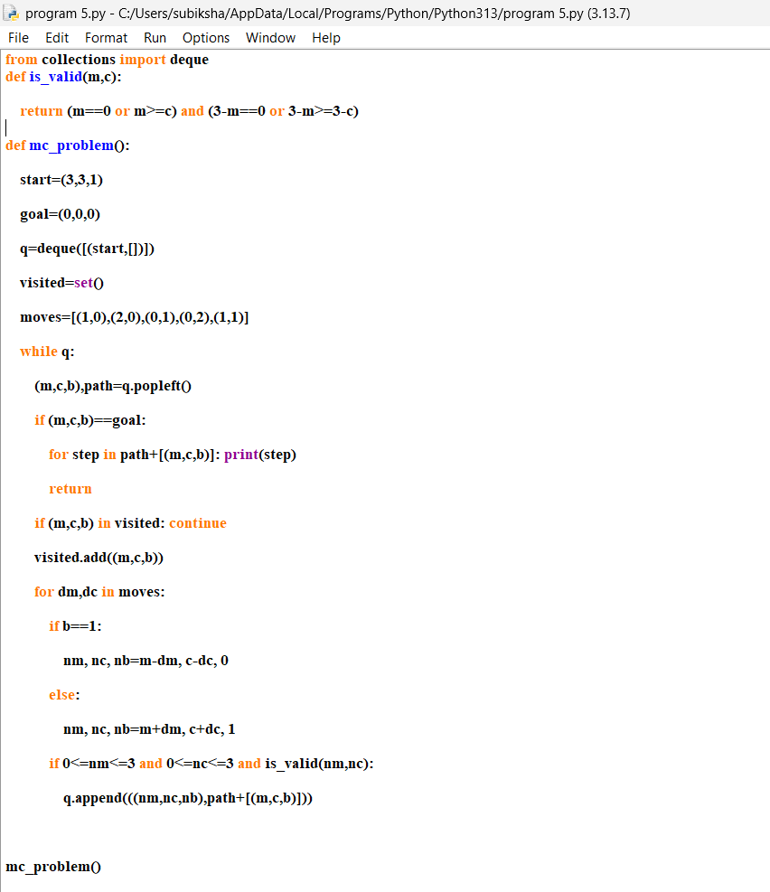

Output

